

|  |  |
| --- | --- |
| **Name** | Amin Mohamed Amin Abdo |
| **ID** | 213 |
| **Sec** | 10 |
| **Group** | 2 |
| **Github Link** |  |
| **Github Page** |  |

|  |
| --- |
| **Examiners Committee** |
| Dr.Ahmed Bayoumi |
| Dr.Shady Elmashad |
| Dr.Abdelhamid Attaby |

***Artificial Intelligence***

By :

Amin Mohamed

“It has been an immense Pleasure to do this project . As it made me apply some of the skills I have been working on and writing a report about the topic that I’m Interested in and have been reading about for a quite long time “

***About the Website in the Project***

The website consists of a **Main HTML** :

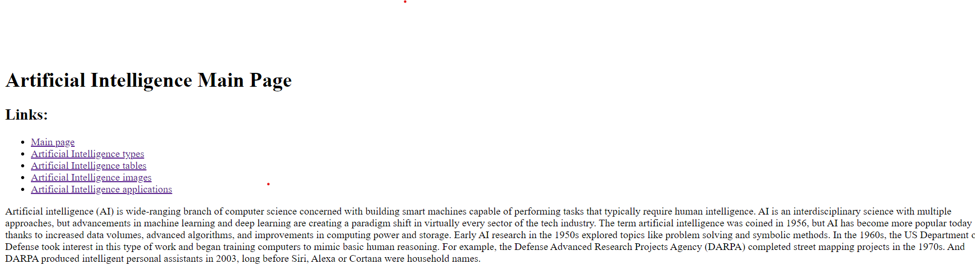

# Source Code :

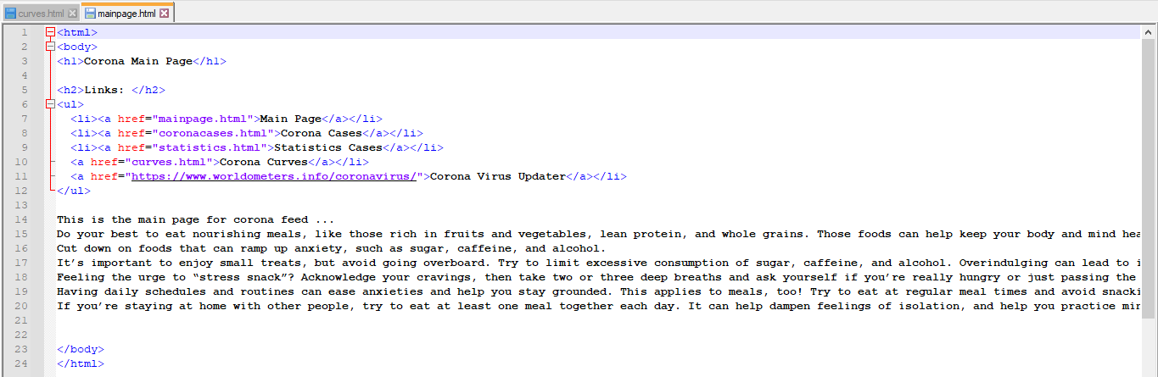

This Website Consists of a **Artificial Intelligence Tbles :**

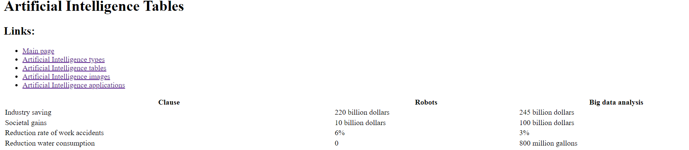

# Source Code:

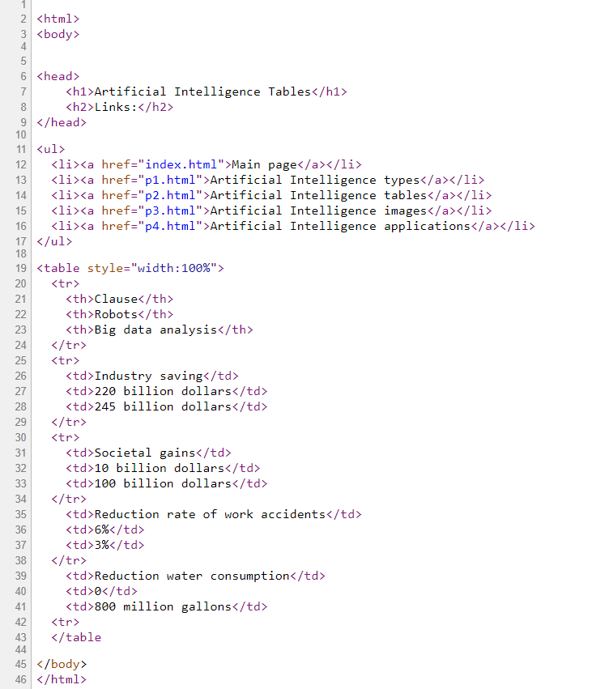

***3***

This Website Consists of a **Artificial Intelligence Images :**

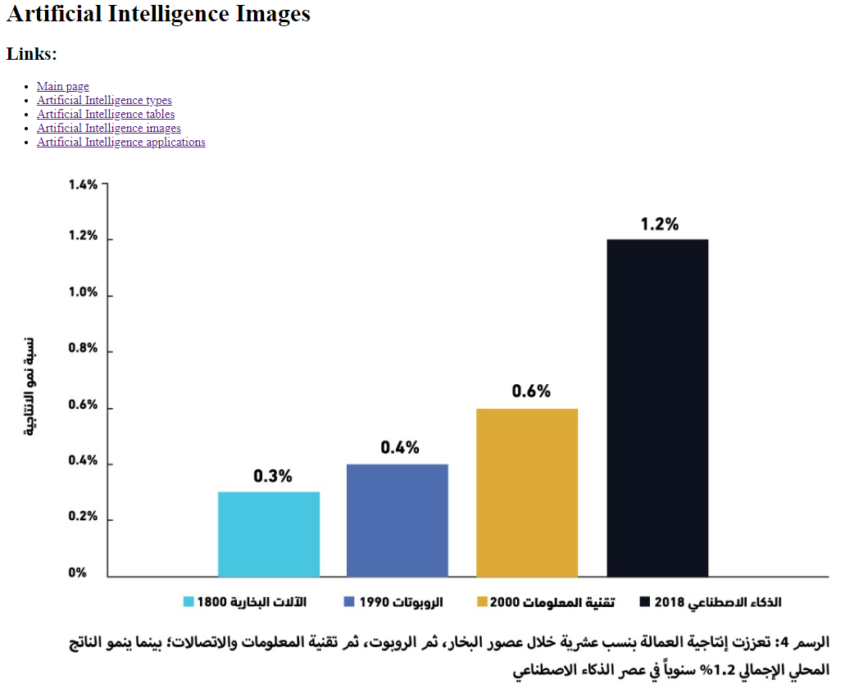

# Source Code :

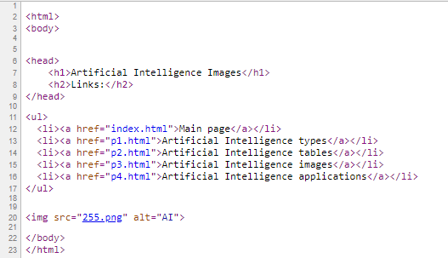

***4***

This Website Consists of **Artificial Intelligence Application**   **:**

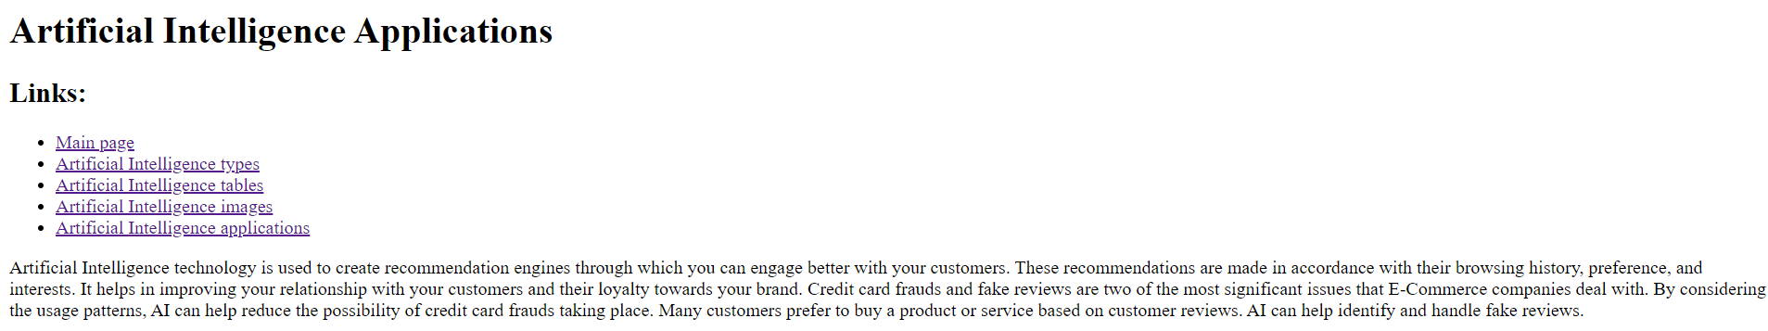

# Source Code :

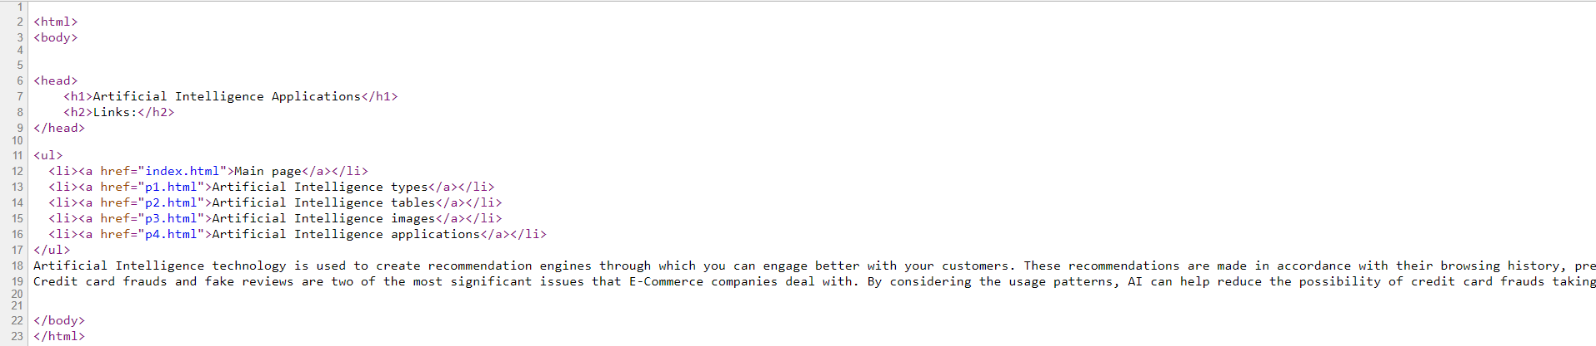

***5***